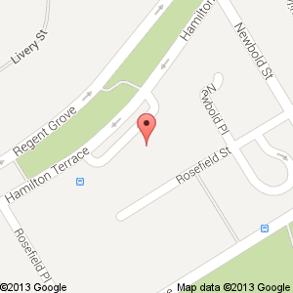

School (front entrance)

Car park (rear of building) accessed via Rosefield Street look for 14 Hamilton Terrace opposite a car park barrier and behind the highest wall

Newbold Terrace